Step 3: Surface alignment

Draft: Written by Dongjun, Nov. 17, 2007. Surface alignment was implemented and applied for 3 mandible images.
Revision 1: Written by Dongjun, Nov. 27, 2007: Algorithm is modified so that surfaces are aligned to the template mandible image. Overlapped plot of the aligned object with the template image is provided for better visualization.

1. Aim

Since it is necessary to align mandibles before shape analysis, we will align them using rotation only with respect to the mass center. Since the shape of mandible is U-shaped, two principle eigenvectors are along the plane, which contains the U-shape, and the remaining eigenvector is perpendicular to the plane. See figure 1 for the eigenvectors of the template. Then by aligning three principle eigenvectors with respect to the center of mass, we can globally align every mandible surfaces.

2. Literature

Shubing’s thesis 4.2.2 page 55. Affine registration.
Li Shen et al. (2004) PCA methods in SPHARM representation.
Styner et al. (2006) Procrustes alignment.
See Ashburner’s book chapter 2.3 attached with this email. He is a world expert on brain image registration and segmentation.

3. Surface alignment: algorithm

: coordinate of each vertex of the template
: mass center of the template
: matrix of coordinate of the template

: coordinate of each vertex
: mass center
: matrix of coordinate

Template Construction
Input:
- Translation: .
- Obtain eigenvector information of the template
  - are eigenvectors and are eigenvalues of .
  - are ordered so that .
  - Adjust direction of : If , then , where is j-th element of the vector .
Output:

[Note] is the indicator function of the set . This is to ignore small values when determining direction.

Alignment
Input: ,
- Translation: .
- Rotation
- are eigenvectors and are eigenvalues of .
- are ordered so that .
- Adjust direction of : If , then , where is is j-th element of the vector .
- Calculate = spherical coordinate of .
- Calculate = spherical coordinate of .
- Rotate about z by .
- Rotate about x by .
- Rotate about y by .
Output: translated and rotated

4. Surface alignment: results

Figure 1 show the template ‘F206-05-09mand’ and its eigenvectors . Red, green, blue lines correspond to when . Figure 2 and 3 show the alignment results of ‘F209-03-01mand’ and ‘M333-17-09mand’. The aligned objects are drawn overlapped with the template to check whether the objects are well aligned. The red surface corresponds to the template and the blue surface corresponds to the aligned object. The figures indicate that objects are well centered and rotated so that it is in the same direction with the template. Note that eigenvectors of the objects coincide with the eigenvectors of the template.

Figure 1. Template (F206-05-09mand) and 3 eigenvectors (eigenvalue: red>green>blue)
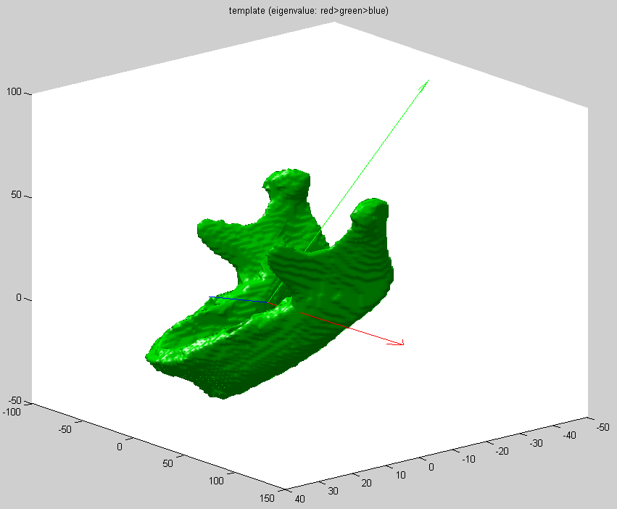
Figure 2. Overlapped plot of ‘F209-03-01mand’ with the template
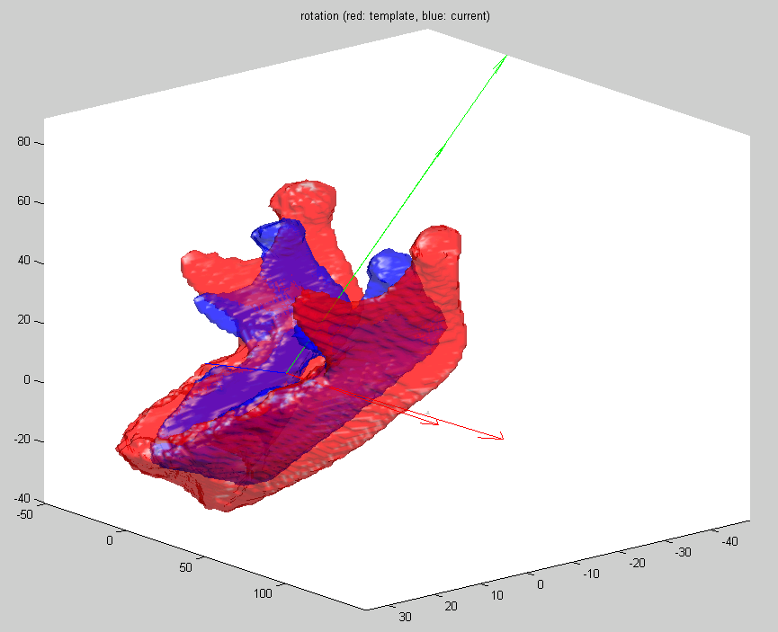
Figure 3. Overlapped plot of ‘M333-17-09mand’ with the template
