Step2: Surface alignment

Draft: Written by Dongjun, Nov. 17, 2007. Surface alignment was implemented and applied for 3 mandible images.

- Surface alignment: algorithm

: coordinate of each vertex
: mass center
: matrix of coordinate

Translation:

Rotation
- are eigenvector and are eigenvalue matrix of .
- are ordered so that .
- Adjust direction of
If , then
What is 1 in the bracket ( ). This line is difficult to understand. ?
- Calculate = spherical coordinate of .
- Rotate about z by .
- Rotate about y by .
- Rotate about x by if , and by if .

[Moo] 1) Side note: There is a command called “norm” in Matlab that computes various vector norms including Lp norm.

2) It seems like you computed the spherical angles of the largest eigenvector and rotated all 3 mandibles to a specific direction. This is one way of aligning and well done. However, all 3 mandibles will align in different orientation from the original orientation.

Can you reformulate this so that you are aligning 2 mandibles to the eigenvectors of the mandible you sent to me? Let us call this mandible “template mandible”. Template means a reference or a target to align into. I checked that template mandible and it looks like in very good shape and direction.

This is easily done in two steps using your formulation (algorithm). You store the information of the eigenvectors (or Euler angles) of the template mandible. Then you rerotate two mandibles into the position of the template mandible again.

3). I can see they are all rotated into a specific direction but it is difficult to see if they are really properly aligned. Try to display two surfaces using the following commend lines

function figure_mesh(tri,coord,FColor,EColor)

figure
p=patch('Faces',tri,'Vertices',coord');
set(p,'FaceColor',FColor,'EdgeColor',EColor);
daspect([1 1 1])
view(3); axis tight
camlight
lighting gouraud
alpha(0.5)

In the main body you call something like
figure_mesh(tri_1,coord_1,’yellow’,’none’);
hold on;
figure_mesh(tri_2,coord_2,’red’,’none’);

It will display two surfaces and show if they align or not.

- Surface alignment: results

Figure 1-3 show the results of ‘F206-05-09mand’, ‘F209-03-01mand’ and ‘M333-17-09mand’. In each figure, top left picture shows the original object and top right shows the object after translation. Bottom left shows eigenvectors of object. Red, green, blue lines correspond to when . Bottom right shows the object after rotation. The figures indicate that all objects are well centered and in same direction after surface alignment.

Figure 1. Translation, eigenvector and rotation of ‘F206-05-09mand’
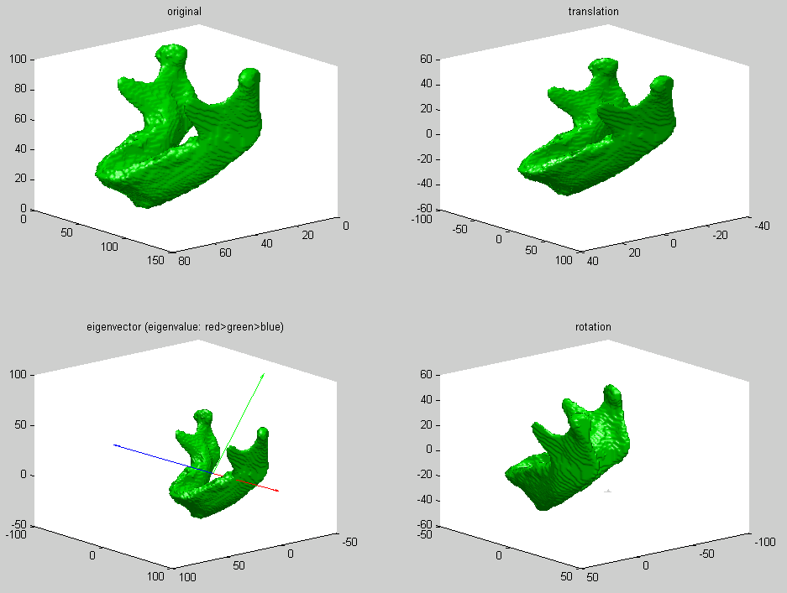
Figure 2. Translation, eigenvector and rotation of ‘F209-03-01mand’
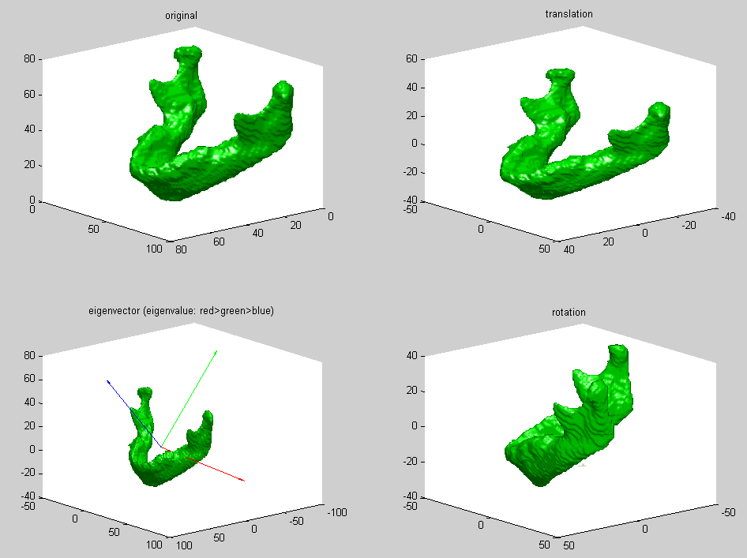
Figure 3. Translation, eigenvector and rotation of ‘M333-17-09mand’
