Longitudinal mandible shape modeling.

We model the gender-specific growth pattern of mandible shapes longitudinally and correlate with other developmental variables. Mandibles are automatically segmented using the Analyze software (http://www.mayo.edu/bir/Software/Analyze/Analyze.html) by theshoding image intensity histogram. The processed binary segmentations are converted to surface meshes via the marching cubes algorithm (Lorensen and Cline, 1987), and a spherical parametrization is computed for the surface meshes using a area-preserving and distortion minimizing spherical mapping (Styner et al., 2006). From the spherical mapping, we obtain the spherical harmonic (SPHARM) representation (Chung et al., 2007) that expresses the surface coordinates as the linear combination of SPHARM basis functions (Figure 1). The anatomical correspondence was established using the SPHARM correspondence and the Proscrustes method (Bookstein, 1997; Styner et al., 2006). This enables us to compare anatomically homologous regions across subjects or within subjects longitudinally. Taking the mandible surface obtained at the youngest age (at 24 months) as a template, the displacement vector between corresponding points between the template and an individual mandible surface will be measured. The obtained 3D displacement vector will be modeled longitudinally in a general linear modeling (GLM) framework (Chung et al., 2003). Figure 2 shows the nonlinear and nonuniform growth pattern in the length of the displacement for nine subjects at four different points on mandible surfaces. For additional data, we will perform a gender specific mandible modeling at each point of mandible.

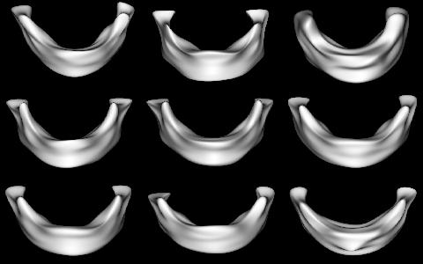  Figure 1. The SPHARM model of mandible for nine male subjects. | Figure 2. Quadratic polynomial fit of surface displacement over months.

Figure 3. Locally varying growth rate per month for nine subjects | Figure 4. Surface area of mandible over month.

References:

Bookstein, F.L., 1997. Shape and information in medical images: a decade of the morphometric synthesis, Comp. Vision and Image Under. 66:97-118.

Chung, M.K., Worsley, K.J., Robbins, S., Paus, P., Taylor, J., Giedd, J.N., Rapoport, J.L., Evans, A.C. 2003. Deformation-Based Surface Morphometry with an Application to Gray Matter Deformation, NeuroImage. 18:198-213.

Chung, M.K., Dalton, K.M., Shen, L., L., Evans, A.C., Davidson, R.J. 2007. Weighted Fourier series representation and its application to quantifying the amount of gray matter. IEEE Transactions on Medical Imaging. 26:566-581.

Lorensen, W.E. and Cline, H.E. 1987. Marching Cubes: A High Resolution 3D Surface Construction Algorithm. Computer Graphics (Proceedings of SIGGRAPH '87). 21:163-169.

Styner, M., Oguz, I., Xu, S., Brechbuehler, C., Pantazis, D., Levitt, J., Shenton, M., Gerig. G. 2006. Framework for the Statistical Shape Analysis of Brain Structures using SPHARM-PDM. MICCAI 2006 Open Source Workshop. Insight Journal. DSpace link: http://hdl.handle.net/1926/215.

