Pilot data
C.2.a - Statistical model of the developing mandible.
Using CT imaging studies and the software Analyze, 9 male mandibles (ages 1.5 to 17 years) were generated in 3D and automatically segmented by threshoding the image intensity histograms. Following this, the processed binary segmentations were converted to surface meshes via the marching cubes algorithm (Lorensen and Cline, 1987), and a spherical parametrization was computed for the surface meshes using an area preserving and distortion minimizing spherical mapping (Styner et al., 2006). Then, from the spherical mapping, the spherical harmonic (SPHARM) representation was obtained (Chung et al., 2007) that expresses the surface coordinates as the linear combination of SPHARM basis functions (Figure 1). Using the SPHARM correspondence and the Proscrustes method (Bookstein, 1997; Styner et al., 2006), anatomical equivalence was next established to enable us to compare anatomically homologous regions across subjects or within subjects longitudinally. After establishing anatomically corresponding points, the youngest mandible was used as a template and the displacement vectors between the template and individual mandibles surfaces were measured. Figure 2 shows the nonlinear and nonuniform growth pattern in the length displacements for the nine male subjects at four different points on the mandible surface. Figure 3 represents the mean growth at each point in male mandibles with the colors signifying regions of least (blue) to most (red) growth.

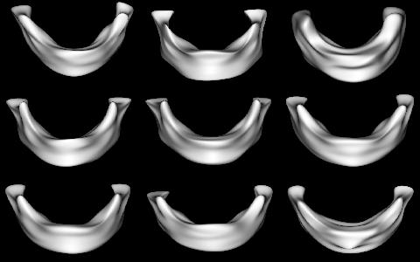  Figure 1. The SPHARM model of the 9 male mandibles. | Figure 2. Quadratic polynomial fit of surface displacement over months.

Figure 3. Locally varying growth rate per month for nine subjects | Figure 4. Surface area of mandible over month.

