Growth Patterns of Mandible Surfaces
Shubing Wang and Moo K. Chung
June 8, 2007
[Abstract]
A quantile-based sub-sampling procedure was used to make the data more suitable for our analysis. Then we have applied the marching cubes algorithm to extract mandible surfaces from the binary segmentation results obtained from the Analyzer program. An area-preserving parameterization is performed on the obtained mandible surfaces and spherical harmonics (SPHARM) representations of the surfaces are given. Surfaces are aligned by the procrustes registration. Two preliminary Mandible growth pattern studies are proposed.

[I. Surface extraction and their SPHARM representation]
Five female and nine male binary segmentation results are given. Since the age span of female Mandible concentrate at age from 16 to 18 years old, while the male Mandibles are from 2 to 17 years, we only performed preliminary analysis only males. Since the size of binary data is large (more 32 MB per Mandible), surface-extraction is very slow and holes always present and it is become very hard to parameterize the surfaces. Therefore a quantile-based sub-sampling procedure is applied to reduce the size of the binary file. Let the original binary file has matrix $X_{0}$ which has dimension $N_{1}×N_{2}×N_{3}$ and all the three numbers are multiples of 10 (we can always make the$X_{0}$ slightly smaller). For new smaller binary matrix $X_{1}$ with size ${{{N_{1}}/{\text{10}}×N_{2}}/{\text{10}}×N_{3}}/{\text{10}}$, each of its entry corresponds to a $\text{10}×\text{10}×\text{10}$sub-matrix of $X_{0}$. If the proportion of 1’s of this sub-matrix is larger than certain percentage (70% is what we use for most files, but to prevent holes in the surfaces, we using a higher percentage for some files), then we give this entry value 1 otherwise 0. Then March-cube method is applied to extracted surfaces from the smaller binary files. 9 male Mandible surfaces are shown in Figuer 1.
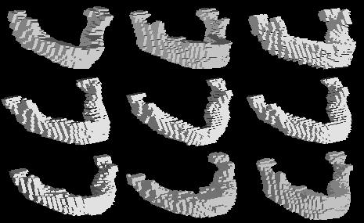
Figure 1. All 9 male Mandible surfaces extracted by Marching-cube.

Area-preserving parameterization is then applied to all the obtained Mandible surfaces. All the surfaces are represented using the spherical harmonic (SPHARM) representing. We found that degree 10 SPHARM representation is proper for the Mandible surfaces as shown in Figure 2.
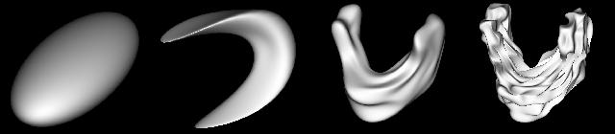
Figure 2. Degree 1, 3, 10, 20 SPHARM representations of Mandible surfaces.

The 9 male mandible surfaces are aligned by Proscrustes registration based on their SPHARM representations as shown in Figure 3.
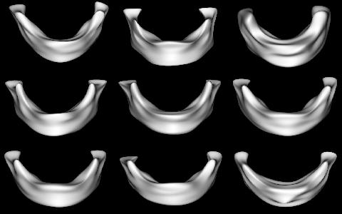.
Figure 3. The aligned 9 male Mandible surfaces.

[II. Growth patterns of Mandible surface: study I]

In this study, we are interested in the growth pattern of individual points on the Mandible surfaces, and especially, we would like to find out the average growth rate of every parts of the Mandible. For every point $(x,y,z)$of a given Mandible surface, we define the norms of this point at age t as
$$N_{t}((x,y,z))=\sqrt{(x−x_{0})^{2}+(y−y_{0})^{2}+(z−z_{0})^{2}}$$
where $(x_{0},y_{0,}z_{0})$is the coordinate of the corresponding point of 2-years old mandible surface (the youngest we have). So the norm measures how much Mandible has grown from the infant at every points. The quadratic polynomials are fitted for observed norms at all the points as shown in Figure 4.
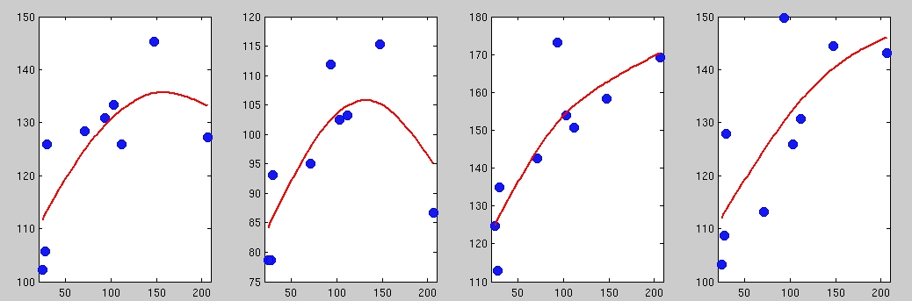
Figure 4. Some examples of norm growth model using degree 2 polynomial models.

We then calculate the mean growth of each points as
$\text{Mean Growth }((x,y,z))=({\hat{N}}_{\text{204}}((x,y,z))−{\hat{N}}_{\text{24}}((x,y,z)))/{\text{180}}$(cm/month).
We then plot the mean growth rate on the 2-year old Mandible surface to show which part of the Mandible grows faster (red), which part grow slow (blue) as shown in Figure 5.
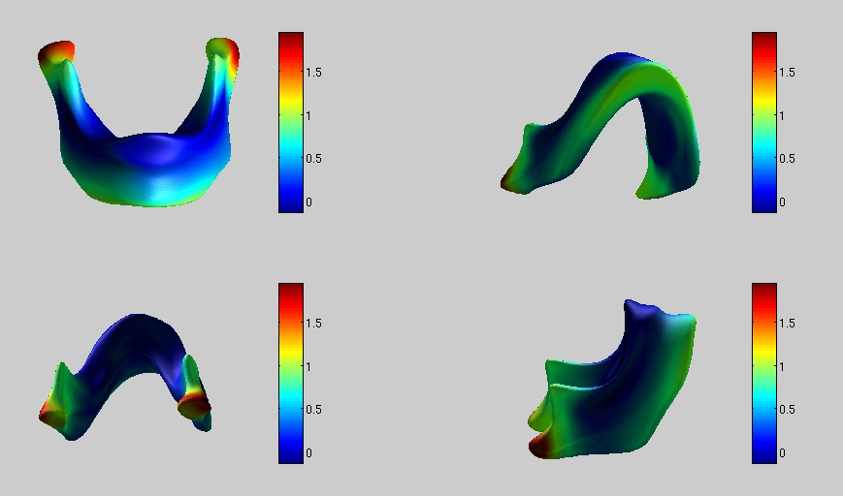
Figure 5. Mean growth rates of Mandibles.

[III Growth patterns of mandible surfaces: study II]

In this section, we are going to establish a model that could predict the Mandible surface at every age. Similar to Section II, but we are going to study how the coordinates grow in stead of norms. For every point, we can have a vector of all x-coordinates from all the subjects, all y-coordinates, from all the subjects, all z-coordinates from all the subjects. We use degree 2 polynomial models to find the growth patterns of x’s, y’s and z's. From the growth pattern models, we can predict x's, y's and z's at all ages, thus able to predict the shape of Mandible at all ages as shown in Figure 6.
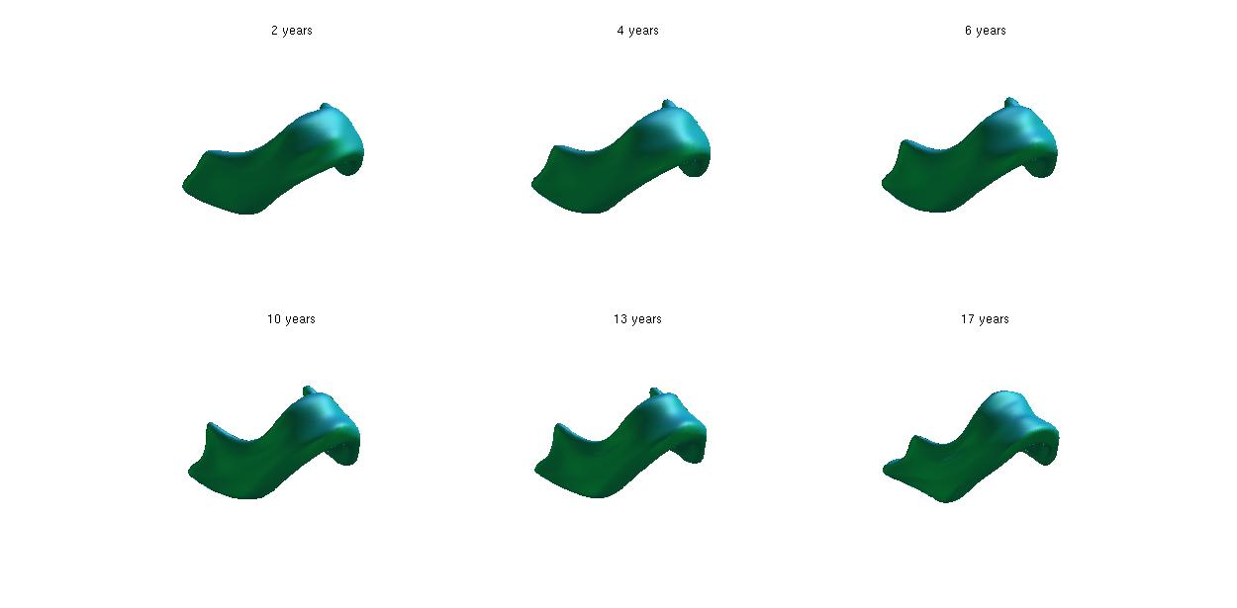.
Figure 6. Predicted Mandible surface at age 2, 4, 6, 10, 13, 17 years old.

[IV. The area growth of Mandible surfaces]

We can also study the area growth pattern of Mandible surfaces based on observed Mandible surfaces using a degree 2 polynomial model as shown in Figure 7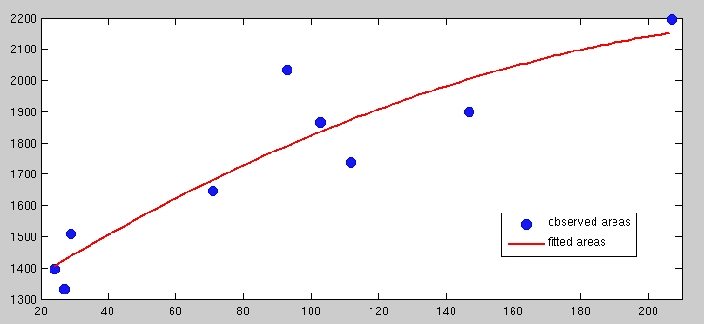
Figure 7. The area growth model of Mandible surfaces.

