Morphometry – preliminary results

We will use magnetic resonance imaging to correlate the anatomy with functional activations. The goal is to quantify patterns of deviation from normal function and anatomy via new computational techniques called deformation-based morphometry (DBM) (Thompson et al, 2000; Chung et al., 2001) and voxel-based morphometry (VBM) (Ashburner et al, 2000).

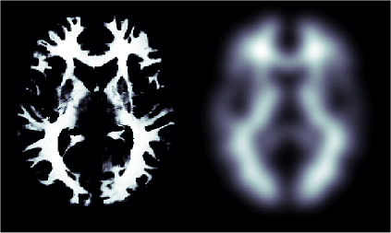 | 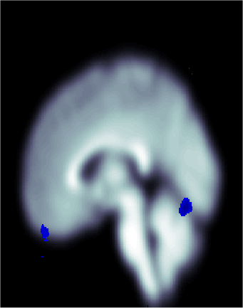
 | Figure 2. VBM applied to autism. Blue is the region of gray matter decrease (P-value < 0.006).

In deformation-based morphometry, the 3D displacement vector field required to register a subject’s brain to another is used to compute morphological tensor maps. From these tensor maps, 3D statistical parametric maps (SPM) are created for a group of subjects to quantify the variations in length, area, volume and surface curvature and to visualize the most variable regions in the 3D whole brain volume (Chung et al., 2001), on the 2D cortical surface (Andrade et al., 2001; Thompson et al., 2000) and on the surface of the brain substructures such as the hippocampus and amygdala (Wang et al., 2001).

18 controls and 13 malenchancolic and 14 nonmalchancolic patients.
Autistic 12 control 15.
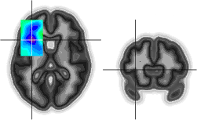 | 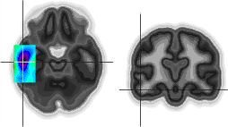
Figure 3. Gray matter decrease in depression P-value < 0.005, White matter increase in depression P-value < 0.005. | Figure 4. Gray matter decrease in depression P-value < 0.0001, White matter increase in depression P-value < 0.0001.

The advantage of this technique over the classical region of interest (ROI) based volumetry is that structural differences can be detected at a voxel level. It has been reported that there is a correlation between depression and the hippocampal atrophy (Sapolosky, 2000). Using the new technique, it is possible to detect local structural differences within the hippocampus and identify exactly what part of hippocampus is responsible for the most anatomical variation between depressed patients and normal controls. The second advantage is that it does not even require a priori knowledge of the ROI to perform the morphological analysis. So we will conduct exploratory analyses of finding possibly new morphological differences in the brain other than the hippocampus and amygdala.

As a part of deformation-based morphometry, surface-mapping strategy has been developed. It requires automatically extracting both the gray/white and white/cerebrospinal fluid interfaces from each subject as triangular meshes (MacDonald et al., 2000). Then fMRI data analysis confined within the gray matter can be achieved (Andrade et al., 2001). Compared to standard 3D whole brain volume based SPM, better sensitivity in specific anatomical situation can be obtained due to the reduction of partial volume effects during 3D volume based image smoothing. Extending the surface mapping strategy further, we will explore the possibility of developing fMRI analysis that facilitates the variations in gray matter density.

References

Andrade, A., Kherif, F., Mangin, J., Worsley, K.J., Paradis, A., Simon, O., Dehaene, S., Le Bihan, D., Poline, J-B. (2001). Detection of fMRI Activation using Cortical Surface Mapping, Human Brain Mapping, 12, 79-93.

Chung, M.K., Worsley, K.J., Paus, T., Cherif, C., Collins, D.L., Giedd, J., Rapoport, J.L., Evans, A.C. (2001). A Unified Statistical Approach to Deformation-Based Morphometry, NeuroImage, 14, 595-606.

MacDonald, J.D., Kabani, N., Avis, D., Evans, A.C. (2000). Automated 3-D Extraction of Inner and Outer Surfaces of Cerebral Cortex from MRI, NeuroImage, 12, 340-356.

Sapolsky, R.M. (2000). Glucocorticoids and hippocampal atrophy in neuropsychiatric disorders. Arch Gen Psychiatry, 57, 925-935.

Thompson, P.M., Giedd, J.N., Woods, R.P., MacDonald, J.D., Evans, A.C., Toga, A.W. (2000). Growth Patterns in the Developing Human Brain Detected using Continuum-Mechanical Tensor Mapping, Nature, 404, 190-193.

Wang, L., Joshi, S.C., Miller, M.I., Csernansky, J.G. (2001). Statistical Analysis of Hippocampal Asymmetry in Schizophrenia, NeuroImage, 14, 531-545.

